**States Program (OptiTrack Interface)**

Inputs:

$$\left[X,Y,Z,q_{1},q_{2},q_{3},q_{4}\right] \& {\left[\dot{X},\dot{Y},\dot{Z},\dot{q_{1}},\dot{q_{2}},\dot{q_{3}},\dot{q_{4}}\right]}^{*}$$

*By iterative derivation (i.e. $,\dot{x}=Δx/Δt$)

Equations:

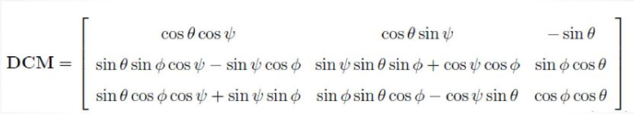

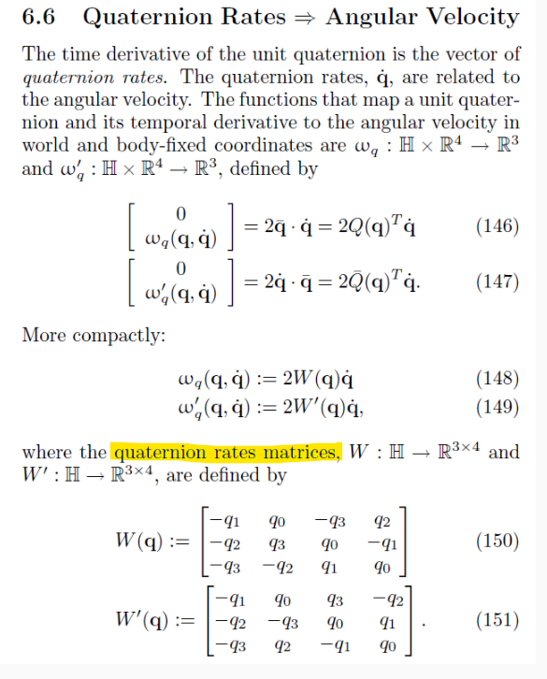

<https://www.gitmemory.com/issue/moble/quaternion/113/493525937>

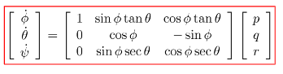

Outputs:

State Vector: $\left[u,v,w,p,q,r,ϕ,θ,ψ,X,Y,Z\right]$

State Rates Vector:

$$\left[\dot{u},\dot{v},\dot{w},\dot{p},\dot{q},\dot{r},\dot{ϕ},\dot{θ},\dot{ψ},\dot{X},\dot{Y},\dot{Z}\right]$$